**Project Design Phase-II**

**Data Flow Diagram & User Stories**

| Date | 03 October 2022 |
| --- | --- |
| Team ID | PNT2022TMID53113 |
| Project Name | Project AI-powered Nutrition Analyzer for Fitness Enthusiasts |
| Maximum Marks | 4 Marks |

**Data Flow Diagrams:**

A Data Flow Diagram (DFD) is a traditional visual representation of the information flows within a system. A neat and clear DFD can depict the right amount of the system requirement graphically. It shows how data enters and leaves the system, what changes the information, and where data is stored.

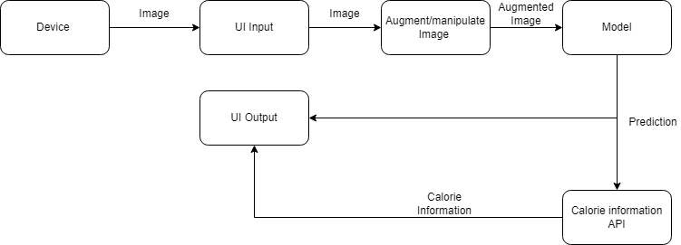

**User Stories**

Use the below template to list all the user stories for the product.

| **User Type** | **Functional Requirement (Epic)** | **User Story Number** | **User Story / Task** | **Acceptance criteria** | **Priority** | **Release** |
| --- | --- | --- | --- | --- | --- | --- |
| Customer | Registration | USN-1 | As a user, I can register for the application by entering my email, password, and confirming my password. | I can access my account / dashboard | High | Sprint-1 |
|  |  | USN-2 | As a user, I will receive confirmation email once I have registered for the application | I can receive confirmation email & click confirm | High | Sprint-1 |
|  |  | USN-3 | As a user, I can register for the application through Instagram | I can register & access the dashboard with Instagram Login | Low | Sprint-2 |
|  |  | USN-4 | As a user, I can register for the application through Gmail |  | Medium | Sprint-1 |
|  | Login | USN-5 | As a user, I can log into the application by entering email & password |  | High | Sprint-1 |
|  | Dashboard | USN-6 | As a user, I can navigate through the dashboard and be able to enter the input image via camera or the gallery. | I can navigate and enter the input. | High | Sprint-1 |
| Customer Care Executive | Enquiry | USN-7 | As a user, I can enquire user feedback and make a report. | I can communicate with the user. | Low | Sprint-3 |
| Administrator | Add/ add information | USN-8 | As an administrator. I can add more fruit information and customer information. |  | Low | Sprint-3 |
|  | Update database | USN-9 | As an administrator. I can update the calorie database in case any change or more information about the product. |  | Low | Sprint-3 |
| Maintenance Team | Update the Deep learning model | USN-10 | As a member of the maintenance team, I can update the model and resolve any technical glitches. |  | Medium | Sprint-3 |